Introduction: Next-generation sequencing (NGS) technology has enabled the systematic interrogation of the genome for a fraction of the cost of traditional assays. Increasingly, NGS is being used to interrogate mutations in heterogeneous clinical samples. Popular variant calling tools including samtools/bcftools and GATK uses naive Bayesian decision rule to call variants and are optimized for homogeneous samples. Recently, some have developed algorithms to call low-frequency or rare variants in heterogeneous samples including VarScan2, Strelka, and muTect. These methods have sensitivity and specificity to call ultra-rare variants (less than 1% minor allele fraction) in pooled samples.

Materials and Methods: RVD2 uses a two-stage approach for detecting rare variants. First, it estimates the parameters of a hierarchical Bayesian model under two sequencing data sets: one from the sample of interest (case) and one from a known reference sample (control). Then, it tests for a significant difference between key model parameters in the case and control samples and returns called variant positions. We used two independent data sets to evaluate the performance of RVD2 and compare it with other variant calling algorithms. The synthetic DNA sequence data provides true positive and true negative positions as well as define minor allele fractions. Data from a cell line was derived from epithelial cells from primary breast tissue (HCC1187) is used to test the performance on a sequenced cancer genome with less than 100% tumor purity.

Results and Discussion: We compare the empirical performance of RVD2 to other variant calling algorithms using the synthetic DNA data set by the false discovery rate and sensitivity/specificity. Samtools, GATK and VarScan2-mpileup all call homogeneous samples even at low depth, but are unable to identify true variants in mixed samples. VarScan2-somatic is able to call more mixed samples. However, as the read depth increases the specificity degrades. Strelka is able to call 10% MAF variants with good performance, but is limited at 1% MAF and below. muTect has good performance across a wide range of MAF levels. But even at the highest depth only has around 0.5 sensitivity for low MAF levels. RVD2 has a high sensitivity and specificity for a broad range of read depths and minor-allele frequencies. As expected the sensitivity increases considerably with read depth at a slight expense to specificity.

RVD2 identified twelve variants in the 44kbp PAXIP1 gene from chr7:154738059 to chr7:154782774. There were eight germline variants and eight somatic mutations. Positions chr7:154754371 and chr7:154758813 appears to be loss-of-heterozygosity events. Some of these mutations are also found to be common population SNPs according to dbSNPv138.
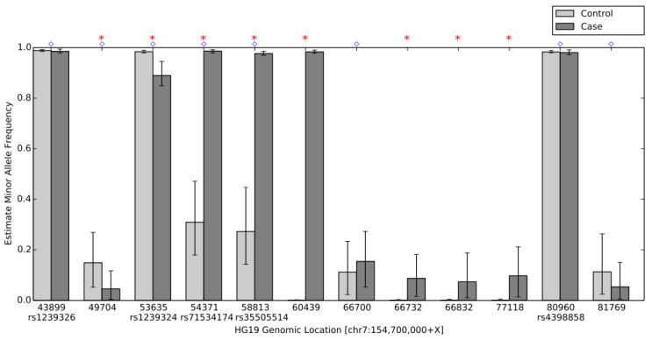
Figure 1. Positions called by VarScan2-somatic, muTect, RVD2 and Strelka in the 44kbp PAXIP1 gene from chr7:154738059 to chr7:154782774. VarScan2-somatic reported 60 positions, muTect called 11 positions, RVD2 called 12 positions and Strelka called 1 position.

Conclusions: RVD2 improves upon current variant classifiers and has higher sensitivity and specificity over a wide range of median read depth and minor allele frequency. RVD2 identified twelve mutations in the PAXP1 gene in a matched clinical breast ductal carcinoma tumor sample; two of which are loss-of-heterozygosity events.

